Symposium on The Applications of Mechanics to Geophysics
June 25-26, 2019 University of California, San Diego La Jolla, CA
http://igppweb.ucsd.edu/~fialko/2019symposium.html

Co-Chairs: Yuri Fialko and Xanthippi Markenscoff
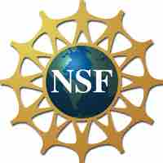 Sponsored by the National Science Foundation & the Green Foundation 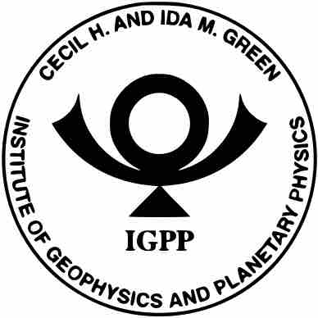

Venue: Engineering Building II, Room 479

Program
Tuesday, June 25
9:15 | Coffee & Muffins
9:30 | Dean Albert Pisano, Jacobs School of Engineering, UC San Diego | Welcoming address
9:40 | James Rice, Harvard University | Long-dormant faults in the sub-surface and their response to nearby fluid injection
10:20 | Nadia Lapusta, Caltech | Study of Potential Biases in Seismologically Estimated Stress Drops of Microseismicity using Dynamically Simulated Earthquake Sources
11:00 | Matt Weingarten, San Diego State University | Linking fluid flow and geomechanics to mitigate injection-induced seismicity
11:40 | Coffee break
11:55 | Xanthippi Markenscoff, MAE, UC San Diego | The mechanics of deep earthquakes
12:35 | Lunch
2:00 | Alain Molinari, University of Lorraine (France) | Fundamental aspects of a new micromechanical model of rate and state friction
2:40 | Sylvain Barbot, University of Southern California | Modulation of frictional strength by grain-size evolution around contact junctions and implications for fault dynamics
3:20 | Coffee break
3:35 | Hiroki Sone, University of Wisconsin-Madison | Viscous deformation of fault damage zones and implications for interseismic development of fault stress heterogeneity
4:15 | Ahmed Elbanna, University of Illinois at Urbana-Champaign | Modeling Earthquake Ruptures With High Resolution Fault Zone Physics
6:30 | Dinner
Wednesday, June 26
8:45 | Coffee & Muffins
9:00 | James Dieterich, UC Riverside (emeritus) | Modeling seismicity induced by fluid injection
9:40 | Greg Mclaskey, Cornell University | Earthquake Nucleation, Seismic Wave Radiation, and Termination of Dynamic Rupture in a 3 m Rock Experiment
10:30 | Kyung-Suk Kim, Brown University | Scale Effects in Friction at Broad Scales: Roughness-Scaling Experiment
11:10 | Coffee break
11:25 | Steve WaiChing Sun, Columbia University | A machine-learning meta-modeling game for generating traction-separation law for frictional interfaces across length scale
12:05 | Yuri Fialko, SIO, UC San Diego | Mechanisms of unsteady shallow creep on active faults in Southern California (and elsewhere)
12:45 | Lunch
2:00 | Paul Segall, Stanford University | The Mechanics of Episodic Caldera Collapse as Revealed by the 2018 Kilauea, Hawaii Eruption
2:40 - 4:00 | Poster Session
4:00 | Adjourn

