Spring 2008 Continuation Report
TIES: Middle School Environmental Education

Team Members:

Jeffrey Chen
Stephen Chyau
Scott Hollwedel
Jae Lee
Carlo Perezortiz
Jaclyn Rapadas
Brandon Reynante
Vincent Varela
Ben Wiljeck
Aram Yoo

TA:

Jacky Ly

Advisors:

Dr. Mandy Bratton
Director, Teams In Engineering Service

Dr. Jan Kleissl
Assistant Professor, MAE Department
1. Introduction

Studies have shown that girls begin to lose interest in the fields of science and mathematics during their middle school years (6th-8th grade) in part due to educational methods and material that are targeted towards boys. The goal of our team is to promote science and engineering interest in middle school girls through engaging interactive educational techniques focused on environmental issues, such as the recent San Diego wildfires, with support from the NSF under the I-TEST program. For this purpose, a low-cost particulate matter (PM) sensor was designed, constructed and tested in order to provide a basis for the establishment of a particulate matter sensor network throughout San Diego County, thereby allowing middle school girls to monitor local air quality. Current plans are to mount an initial sensor on the Preuss School. A curriculum based on this PM sensor is currently being developed. Moreover, lesson plans focused on hand-held sensors with multi-parameter measuring capabilities are being implemented in local classrooms.

An interactive website is being developed that utilizes a novel data mapping tool to provide students with access to environmental measurements by other students across the county, such as PM and water quality data. The website also contains a database of lesson plans developed by the team for teacher use, student-to-student forums and teacher-to-teacher forums, and it will allow students to receive mentoring support from the TIES team. Additionally, technical and educational support is offered to teachers implementing the hand-held sensor curriculum in their classrooms. The team is also peripherally involved in the development of a collaborative role-playing game about environmental awareness, titled Antarctica, in conjunction with the San Diego Supercomputer Center.

2. Quarter Goals

This quarter the team was split into two main sub-teams: a Sensor sub-team and an Education sub-team. The Sensor team focused on aspects of the project related to the actual PM sensor, and the Education team developed curriculum and assisted the I-TEST teachers. The following goals were set at the beginning of the quarter:
- Design and test humidity feedback control system
- Create wireless network to access the PM data
- Develop lesson plan based on PM sensor
- Assist I-TEST teachers in their classrooms
- Test Antarctica game and provide feedback
- Mount PM sensor system on the roof of the Preuss School

Gantt charts for both the Education sub-team and the Sensor sub-team can be found in the Appendix. All of the goals were achieved, with the exception of mounting the PM sensor on the roof of the Preuss School. Instead, the team was able to mount the sensor on the roof of EBU-I, which will allow for further testing of the system before the actual mounting on the Preuss School. Administrators at the Preuss School have set July as the earliest possible mounting date.
3. Particulate Matter Sensor System

A main goal of the Middle School Environmental Education team is to mount a particulate matter sensing system on middle schools. An indoor PM sensor was purchased from APC Netbotz, and modifications have been done to allow the sensor to be used in outdoor conditions. Below is a diagram that shows how the sensor works.

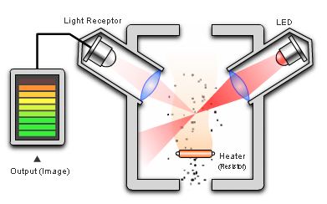

Figure 1: PM sensor diagram

This sensor is the Shinyei Corporation’s PPD20V particulate matter sensor, which is internal to the Netbotz system. As particulate matter (1 micron or larger in size) enters the sensor, an updraft causes the particles to move into the light path of the LED. The particles reflect some light towards the focusing lens on the left of the sensor. A light receptor receives the light and outputs a voltage drop proportional to the amount of light received. In this way, particle concentration is correlated to reflected light.

The particulate matter sensor system consists of many components including a fan to produce in/out airflow, Netbotz PM sensor box, Netbotz 320E data acquisition rack, a humidity feedback control system, and an extensive wireless network system for efficient data transference. The fan and Netbotz PM sensor box are located within an acrylic enclosure and are specifically designed for long-term measurement purposes. The Netbotz 320E data rack connects to a Linksys Gateway router. Data acquisition is generated by connecting the Netboz 320E data rack directly onto Netbotz PM sensor with a PS2 cable. In order to access the data, a high gain antenna is attached to the Gateway router via a 30ft extension cable, and another high gain antenna is connected to a laptop, which is running the Netbotz program. To protect the equipment from the elements, enclosures designed for long-term sustainability are used to house all of the electronic components. One enclosure protects the data rack and Linksys Gateway router. Another enclosure is solely used to sustain the PM sensor, humidity sensor, and fan to allow measurement of the particulate matter that flows through the system. More info on these enclosures can be found in the Winter 2008 report. PVC conduit is used to protect all of the wires associated with the enclosure, allowing for a weatherproof system.

Wireless Network

Data is accessed from the PM sensor by utilizing a wireless network, which initially required the use of a laptop connected directly to the Netbotz data rack. During the first setup on top of EBU I for long term testing, it was found that the laptop does not need to be directly connected to the data rack, therefore making the fabrication of the enclosure easier. We hooked up the antennae to the router directly after taking off the factory antennae from the router. Then the power was hooked up to each of the units, which were: the router, the fan, the Netbotz data rack, and the sensor. We then lined up the new antennae with Jan’s office, in which we had our second antennae hooked up to the computer through the use of a wireless USB adapter, which has an “unscrew” -able wireless antenna. This was then hooked up the aftermarket antennae and then placed outside of Jan’s office.

Extensive testing of the wireless network was also performed in order to verify the operating parameters. The manufacturer specified a range of approximately 2 miles (please refer to the WI08 report for full specs on the antenna system), and it was necessary to confirm this to ensure that a connection could be made with the system when mounted on the Preuss School. Testing verified the range of the antennas, and it was also discovered that a signal could be transmitted through objects of a considerable thickness, including trees and buildings, which indicates that direct line of sight between the antennas may not be completely necessary.

Data Acquisition Program

The previously modified source code for converting graphical data from the NetBotz Advanced View program to excel format, titled “class1.cs” (see FA07 report for more information on the program), currently operates by extracting 8 hours worth of prior data, and converting the data points into an excel file. This quarter the program was modified to retrieve 5 minutes worth of previous data, although this implementation has not been tested. Also, after installing the C# program on the TIES computer, it is now possible to access all the API documentation provided by NetBotz. These documents detail what a certain function does. This program is available on the TIES website.

Automated Data Upload

A MATLAB program was created to allow the PM data to be automatically uploaded to the TIES website. The MATLAB program works by storing the file into the Windows startup folder. Whenever Windows boots, the program will convert excel files into a graph and store it in a picture file (.jpg). Then, DOS is opened in the background to upload the picture file to the TIES server. The MATLAB code is available on the TIES website under Spring 08, although some future modification is required.

4. On/Off Feedback Control System

How the On/Off Feedback Control System Works
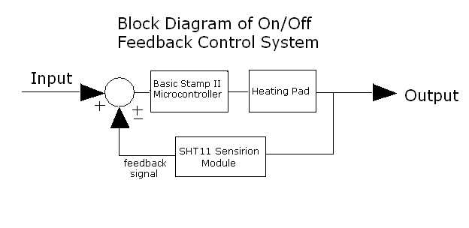
Figure 2: Block Diagram of Feedback Control System

The figure above provides a block diagram of a simple on/off feedback control system. The input is the desired relative humidity level within the Netbotz box containing the particulate matter sensor. The Basic Stamp II microcontroller is the control element that commands the overall system, which tasks to perform. For this project, the microcontroller was programmed to perform two tasks; the first and utmost important task was to work in conjunction with the solid-state relay to power the heating pad. The second task was to use the SHT Sensiorion Temperature/Relative Humidity Sensor to relay a feedback signal back to the BSII microcontroller.

Since the basic requirement of an on/off feedback control system is a switch, a solid state relay was used to allow 110 volts of alternating current to power the Omegaplux heating pad. In order to implement a closed loop system, the temperature/relative huumidity module was used as a feedback signal to continuously obtain measurements to the Basic Stamp II microcontroller. The Basic Stamp II microcontroller would then determine whether the heating pad is necessary to set the relative humidity to an ideal level.

Design Configurations

Since the particulate matter sensor only works within a specific temperature/relative humidity range, an on/off feedback control system was developed to consistently measure the humidity and adjust the relative humidity to the ideal level. The maximum humidity level at which the PM sensor accurately functions is 95%, therefore the humidity must be maintained lower then that value. To implement an on/off feedback control system a Sensirion SHT11 temperature/relative humidity sensor is connected to a Basic Stamp II microcontroller and programmed to turn the heating pad on in conjunction with turning the fan off. Various factors affect the performance of sensor, one of which includes airflow. When the heating pad is turned on, it is imperative that the fan be turned off for the temperature/relative humidity module to obtain accurate measurements because airflow has a tendency to skew the temperature/relative humidity measurements. Furthermore, the airflow drawn by the fan allows convection to disperse the heat throughout anterior walls of the acrylic enclosure, rather than transferring the heat to the Netbotz box through conduction.

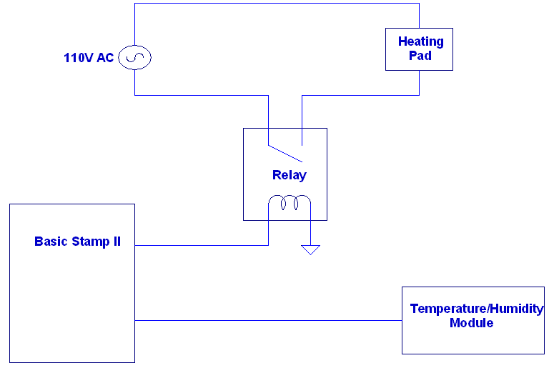

Figure 3: Circuit Diagram of the On/Off Feedback Control System

The figure above is an updated circuit diagram of the control system of the basic elements that make up the overall system. Specific details on the electronics and power source connections may be found in the following section.

How the Program Works

The PBasic program is used to command the Basic Stamp II microcontroller to function effectively as a feedback control system to. Most of the syntax has been taken from the source code that came with the humidity sensor. If needed, the program is available on the Parallax website on the Sensirion SHT11 page. Memories saving alterations have been implemented for future projects that require PBasic programming by writing the code in the main portion of the program.

The program code basically commands BSII microcontroller to output 5 volts at pin2 when the humidity level reaches 90 percent. While the BSII microcontroller continuously measures the relative humidity at a specific sample frequency, the program commands the fan to turn off. Once the relative humidity falls below 85 percent, the program code commands BSII microcontroller to set the voltage at pin2 back to original value of 0 volts. The source code is attached in the appendix.
NPN Transistors

In order to simplify the programming using the PBasic language and develop a relatively inexpensive switch for the fan, two NPN transistors are used in a signal inverting circuit to arbitrate the power input to the fan. This allows both the heating pad and fan control to be controlled using the same input pin on the Basic Stamp II Board of Education. The current circuit setup allows the fan to run continuously regardless of problems that may occur within the Basic Stamp II BOE. The underlying reason for this decision is that because the fan runs independently from the BSII microcontroller, the data being obtained from the PM sensor will always remain consistent regardless of whether the microcontroller is working properly. However, one of the disadvantages of configuring the transistors to their current setup is the risk of overheating and possible fire hazard, which is unfavorable considering that they are enclosed in an airtight polycarbonate enclosure. However, specifications on the Basic Stamp II BOE justify that overheating should not be a problem. All of the circuit components located inside the NEMA 4X enclosure will not generate enough heat to cause problems or even self-destruct. However, if the humidity sensor system stops working or the enclosure is hot when opened in the future, it is important to consider these factors.

Another important design consideration is that a 12V DC source used to power the fan is also being used to run the BS II microcontroller. Hence, one DC source is being used to power two individual components. The motive behind this design is to make the overall system ergonomic by reducing the number of cords and wires. IMPORTANT NOTE: DO NOT POWER THE BSII BOE WITH ANYTHING MORE THAN 12V OR LESS THAN 5V. Check any source to make sure it is within that range or the BSII microcontroller will not function properly.
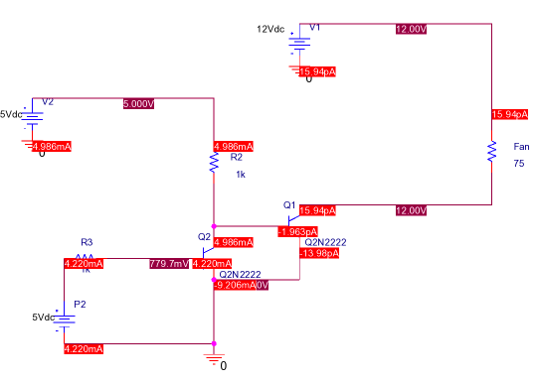
Figure 4: Circuit Simulation when Pin 2 Is High
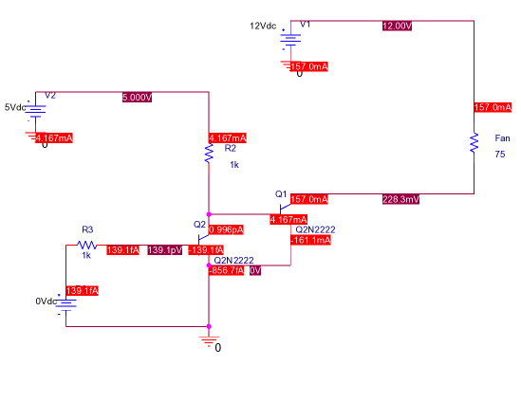
Figure 5: Circuit Simulation when Pin 2 is Low (Normal Operation)

It is important to note from these two diagrams that the current flowing through the fan is roughly 157 mA when pin 2 is set to low and about 14 pA when pin 2 is set to high. Overall, this circuit functions effectively as a switch.

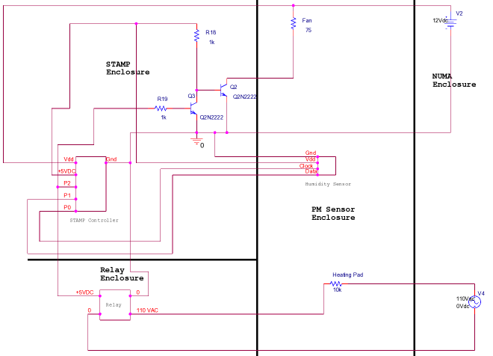
Figure 6: Diagram of Electronics Spatially Organized
Purchased Components

Solid-State Relay

The PM sensor system must be maintained at a certain humidity level to function properly. In order to ensure the accurate operation of the system, solid-state relay (SSR) was purchased to complement the temperature and humidity sensor and BASIC stamp system we had from the previous quarter. When the humidity level becomes exceeds 90 percent, the sensor sends back a signal to the BASIC stamp system to turn on the SSR switch of the heating pad immediately. And when the temperature becomes too high or when the humidity level drops to ideal level, the sensor sends signal back to the BASIC stamp and shuts off the heating pad through the SSR switch.

The SSR is an electronic switch controlled by a low voltage signal. The SSR was chosen because it is much faster than the electromechanical relay; its switch time is in the order of nanoseconds. Without any moving parts or wear, the SSR has an increased lifetime. And its small size, and cheap price also complements well with our entire project as a whole.

After some research, we decided on SSR10A with input voltage of 3-32 VDC and input current of 15mA. The output voltage is 48-380VAC and maximum load current is 10A. We did not have much restrictions on the SSR that we need, thus we simply searched for the cheapest one possible. Product specifications may be obtained at the following website: http://www.futurlec.com/Relays/SSR10A.shtml

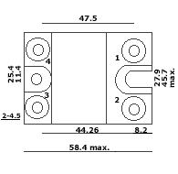
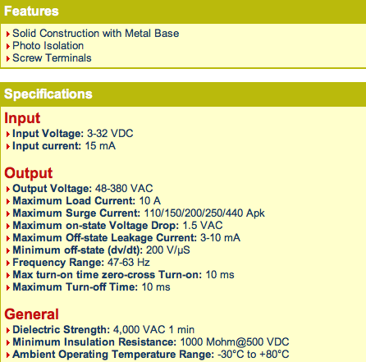
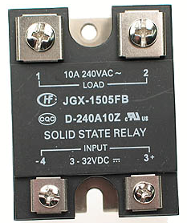

Figure 7: Solid-State Relay
Equipment Enclosures

In order to complete the goal of mounting the sensor system on top of the EBU1 building, all our systems must be stored in a weatherproof enclosure, including the BASIC stamp and solid-state relay to ensure that the system will be working properly in all types of weather. To accomplish this, we purchased a NEMA 4X transparent box enclosure from Digi-Ley. The enclosure is made out of very strong yet flexible polycarbonate material with built in drills and silicon lining on the cover to ensure the security of the cover and prevents from any dust particles or rainwater to pass through. The transparency also allows easy regular checkups on the system without having to open the cover. We have selected the dimensions of 6.73" x 4.76" x 2.17" (170.94mm x 120.9mm x 55.19mm) which fits the BASIC stamp board securely. The specifications of this product are located in the Appendix.

For the enclosure of the SSR, we have also chosen polycarbonate as the material. However, we decided to construct our own enclosure for SSR since this system is much sturdier and we can learn more from building our own enclosure. A piece of polycarbonate material with dimensions 12”x12”x1/4” was initially purchased. The AutoCAD program was used to design the layout of the enclosure and then the LaserCamm machine was used to cut each component with the utmost accuracy and precision. The polycarbonate enclosure was fabricated using drills, taps, and flat head screws. In the end, heavy-duty silicon adhesive was used to seal any gaps between the cut pieces.

Product specifications may be obtained at the following two websites:
http://dkc1.digikey.com/us/en/mkt/NewT073/BUD/NEMA.html
http://www.budind.com/pdf/hb2724.pdf

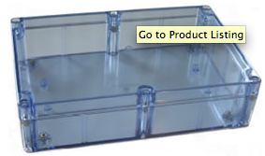
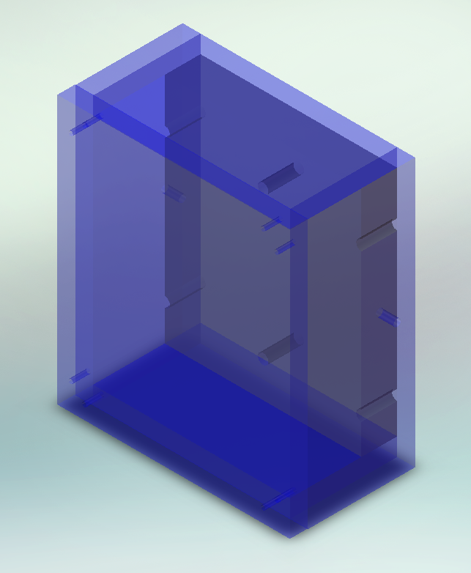
Figure 8: a) NEMA 4X enclosure and b) Polycarbonate Solidworks Model
5. PM Sensor Mounting

Preuss School

The Preuss School has given the MSEE team permission to mount the PM sensor on their roof. The following diagram shows the roof of the Preuss School where mounting is planned, which is located on Building F (see FA07 and WI08 reports for more details).

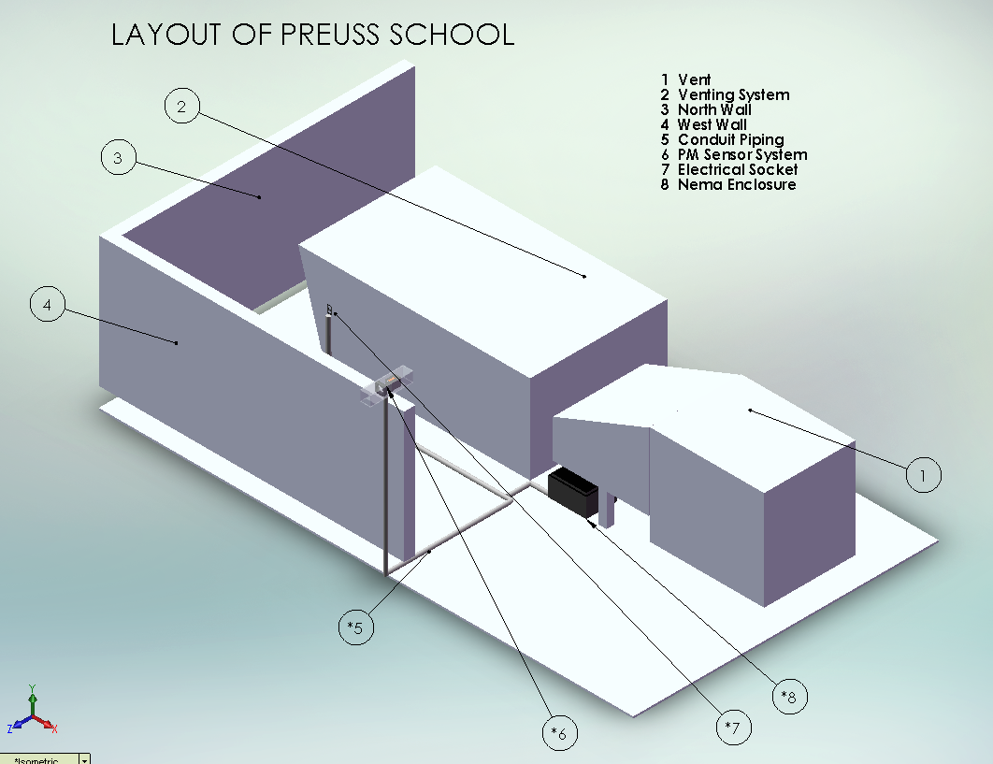
Figure 9: Model of Preuss School roof with layout of sensor system

It was originally planned that mounting on the Preuss School would occur this quarter, but the Preuss administrators requested that the team wait until July. The main contacts at the Preuss School are the following:

Table 1: Preuss School Contact Info
Name | Position | E-mail | Phone
Chris Laitinen | Facilities Coordinator | claitinen@ucsd.edu | (858) 658-7428
Caesar Dispo | Business Manager | cdispo@ucsd.edu | (858) 658-7410

Chris Laitinen is the primary contact, and he should be contacted first. Caesar Dispo is Chris’s supervisor, and it is usually not necessary to contact him.
Mounting on EBU-I

Since the plans to mount on the Preuss School were delayed, it was decided to mount the entire system on the roof of EBU-I to perform extended testing. This location allows easy access and provides a simulation of the actual set-up that will occur on the Preuss School. Current plans are to keep the system mounted for at least a couple months so that the team can fix any problems that arise during testing.

The system was mounted similarly to the layout planned on the Preuss School. The PM sensor enclosure is mounted on top of a steel pole, with the feedback control system placed nearby on a stack of cinderblocks. The steel equipment enclosure is set on the floor, and the wireless antenna is mounted on a tri-pod 30 feet that has been aligned with the second antenna in Jan’s office (EBU-II room 580). Data can be obtained from the PM sensor by connecting the second antenna to the TIES laptop and running the NetBotz Advanced View program. Below are photos from the mounting process.

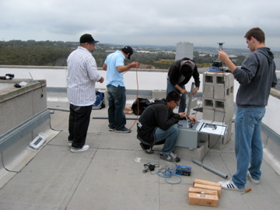
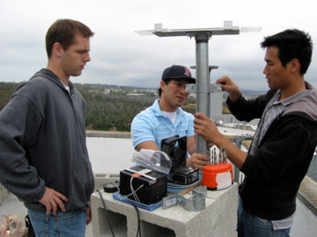

Figure 10: Pictures of the EBU-I mounting procedure

More pictures of the mounting process and set-up can be found on the TIES website. All of the equipment is currently operational, and it is suggested that al components are checked frequently to promote early detection of problems. One problem encountered already is that the outlet through which everything is powered needed to be reset after a week of testing. Pressing the reset button on the outlet face can easily fix this. The roof of EBU-I can be accessed through the 7th floor. Contact to get approval for going to the roof is made through Francesco Carusi in the Dean’s Office:

Table 2: Contact info for EBU-I roof access
Name | Title | Office | E-mail | Phone
Francesco Carusi | Director of Administration | EBU-I 7128 | fcarusi@ucsd.edu | (858) 822-4690
6. Educational Outreach

Expand Your Horizons Event

Global Warming was the lesson plan topic presented at EYH, which is an annual educational conference geared toward increasing math and science interest middle school girls. The conference was held at the University of San Diego this year. There was a total of three lesson plans with about twelve students participating in each of them. YouTube videos were used to show that four polar bears have died from drowning this past year, which is why they are an indicator species of too much ice melting. After the videos were shown, toy polar bears were placed on top of blocks of ice in a tub of water. Inside this tub, there were tubes of hot water and cold water with red artificial coloring in the hot water tube and blue artificial coloring in the cold-water tube. As the red coloring would rise up, the blue coloring would fall down showing the Convection Cycle. As the water temperature reached a warmer equilibrium point, the block of ice would melt and the polar bear would fall off the ice indicating that they are an indicator species. The water level of the whole tub would also rise due to ice melting. This presented to students the danger that flat islands such as New York may possibly flood in the future.

I-Test Classroom Visits

Throughout the quarter, TIES students provided technical support to teachers from various San Diego middle schools during the lessons they taught using the Vernier LabQuest handheld sensors. With a curriculum covering topics ranging from global warming to light absorption, the teachers had the students observing the environment in fun and engaging ways. The fabric experiment detailed below is one such lesson:

Fabric Experiment
This experiment involves students placing different colored fabrics on temperature probes and shining light on these fabrics to see the rate at which heat is absorbed. The fabrics vary based on color and thickness and this experiment teaches students which colors and thicknesses absorb most heat.

Table 3: Teachers involved in the I-TEST classroom visits
Teacher | School | Contact Info
Buddy Young | O’Farrell School | bernardyoung551@gmail.com
Jen Chranowski | O’Farrell School | jchranowski@hotmail.com
Roger Wynn | Mountain Empire High School | wynn@cts.com
Rose Ann Morris | Mountain Empire High School | rmorris@meusd.net
Erik Ong | San Ysidro Middle School | captaineo70@hotmail.com
Dave Tice | Black Mountain Middle School | dtice@powayusd.com

After each lesson the TIES team is required to fill out a survey in order for the I-TEST research team to gather data about the lessons.
Link to post-visit survey:
http://www.grgsurvey.net/cgi-bin/rws3.pl?FORM=LessonReportCard
MSEE Developed Curriculum

The Education sub-team also developed environmentally themed curriculum. The two lesson plans created this quarter are described below. Both lesson plans are attached in the appendix.

Solar Power Lesson Plan

In this newly developed lesson plan, it will first be emphasized that solar energy is great because it’s renewable and does not pollute as opposed to fossil fuels which are non-renewable and do pollute. Then students will shine a flashlight at the different positions onto the solar panel in the solar panel education kit. This solar panel will be connected to a voltmeter so that voltage can be read when the flashlight is shining on different positions. This will teach students the disadvantage of solar power energy, which is that certain positions of the sun give more energy than others and that certain parts of the world receive more of this energy than other parts.

Ideas for alternative energy lesson plan found at the following sites:
www.eere.energy.gov/education/lessonplans/pdfs/transportation_alternativefuels.pdf
www.eere.energy.gov/education/lessonplans/pdfs/solar_photovoltaicselectricity.pdf

Sensor Lesson Plan

Part I
This first part of the lesson plan involves showing students how their eyes work as a sensor by shining a strobe light over water flowing out of small holes of a cup and varying the frequency of the strobe light until the streams of water appear to be water droplets.

Part II
This second part of the lesson plan involves using a multi-meter to measure the resistance of the photo resistor and setting the overhead to shine on the area of colored paper. The photo-resistor is placed in a fixed position relative to the paper. The photo resistor measures light reflected off of the paper. The resistance value of that paper is used to relate it to its reflective properties.

Part III
The third part of the lesson plan involves teaching students how to use the hand-held PM Sensor to collect data at various locations. This shows the students the sites that had the most particulate matter in the air which tells then about the air quality in various locations.

Idea for sensor lesson plan found at the following site:
http://www.matscieng.sunysb.edu/ctsr/ret/intro-to-sensors-lesson-plan.pdf

Interactive Website

An interactive website is being created on the TIES website which will allow students to have access to our PM data and will include a database of lesson plans. The short-term goal of the interactive website is to first have this used by Pruess School with their sensor which will be mounted this July. The long term goal of the interactive website is to allow it to have data that PM sensors gather at various schools across San Diego which will have PM sensors. This will allow students and teachers throughout San Diego to interact with data as a network of information. Not much was done with regard to the website this quarter as Jeff Sale (jsale@sdsc.edu) is currently installing it on the TIES website. Please refer to the WI08 MSEE Final Report for more information.

Antarctica

Antarctica is a collaborative educational computer game that is being developed by Steve Cutchin at the SDSC, which will be used in classrooms. The game was tested and reports were sent to Jan Kleissl and Steve Cutchin (cutchin@sdsc.edu) regarding technical difficulties and possible ways for game improvement. The theme of this game is saving Antarctica from UV radiation.

The game can be downloaded from the following link:
http://visservices.sdsc.edu/projects/gamegrid/

A Quick Start Guide is available on the TIES website under Spring 2008 Documents.

7. Budget

Table 4: Itemized budget for MSEE Team SP08
Item | Cost
Lesson Plan Supplies | $57.59
NEMA 4X Enclosure | $28.34
Solid State Relay | $25.90
Polycarbonate Enclosure Material | $14.91
Travel | $134.60
Education and Research Expenses | $30.00
Team Building | $38.63
Total | $329.97

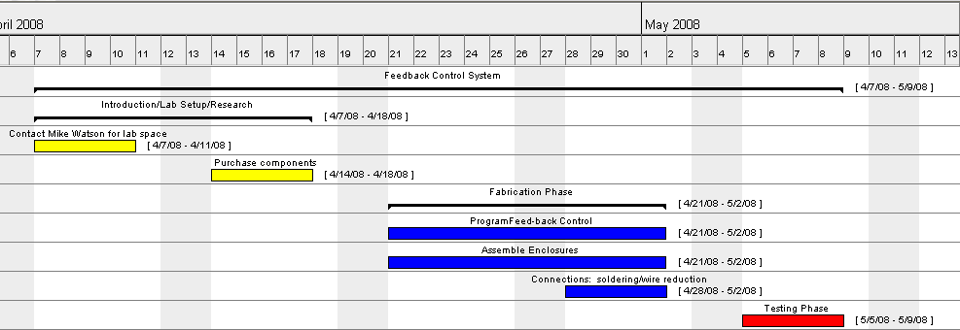
8. Appendix

A. Sensor Team Gantt Chart

B. Education Team Gantt Chart

MSEE Education Team - Gantt Chart
Tasks | Start Date | Duration (weeks) | End Date
Develop PM Sensor lesson plan | Week 3 | 5 | Week 8
Develop environmental lesson plan to teach at Preuss | Week 3 | 5 | Week 8
Visit Preuss and teach lessons | Week 8 | 1 | Week 9
I-Test Teacher classroom visits (Vernier handheld sensors) | Week 2 | 8 | Week 10

C. Basic Stamp Code
(Available on TIES website)

' ==============================================================================
'
' File...... humidititycontroller.BS2
' Purpose... Humidity Control System using SHT sensor and hot pad for MSEE
' Author.... Scott Hollwedel
' E-mail.... shollwed@ucsd.edu
' Started... 10 APR 2008
' Updated...
' Credit for subroutines to Jon Williams of parrallaxinc.com
'
' {$STAMP BS2}
' {$PBASIC 2.5}

'
' ==============================================================================

' ------------------------------------------------------------------------------
' Program Description
' ------------------------------------------------------------------------------
' This program takes humidity input from SHT1x data and uses it to control the use of a
' heating pad to control humidity in sensor box.
'
' For detailed information on the use and application of the ** operator,
' see Tracy Allen's web page at this link:
'
' -- http://www.emesystems.com/BS2math1.htm
'
' For Tracy's SHT1x code [very advanced]:
'
' -- http://www.emesystems.com/OL2sht1x.htm
'
' For SHT11/15 documentation and app notes, visit:
'
' -- http://www.sensirion.com

' ------------------------------------------------------------------------------
' Revision History
' ------------------------------------------------------------------------------

' ------------------------------------------------------------------------------
' I/O Definitions
' ------------------------------------------------------------------------------

HeatPad CON 2 ' heater switch
ShtData CON 1 ' bi-directional data
Clock CON 0

' ------------------------------------------------------------------------------
' Constants
' ------------------------------------------------------------------------------

ShtTemp CON %00011 ' read temperature
ShtHumi CON %00101 ' read humidity
ShtStatW CON %00110 ' status register write
ShtStatR CON %00111 ' status register read
ShtReset CON %11110 ' soft reset (wait 11 ms after)

Ack CON 0
NoAck CON 1

No CON 0
Yes CON 1

MoveTo CON 2 ' for DEBUG control
ClrRt CON 11 ' clear DEBUG line to right

MaxHum CON 90 ' Max humidity in percent for ideal conditions

' ------------------------------------------------------------------------------
' Variables
' ------------------------------------------------------------------------------

ioByte VAR BYTE ' data from/to SHT1x
ackBit VAR BIT ' ack/nak from/to SHT1x
toDelay VAR BYTE ' timeout delay timer
timeOut VAR BIT ' timeout status

soT VAR WORD ' temp counts from SHT1x
tC VAR WORD ' temp - celcius

soRH VAR WORD ' humidity counts from SHT1x
rhLin VAR WORD ' humidity; linearized
rhTrue VAR WORD ' humidity; temp compensated

status VAR BYTE ' SHT1x status byte

humidity VAR WORD ' whole number humidity percent
HeatPadStatus VAR BIT ' indicator bit for heating pad

' ------------------------------------------------------------------------------
' EEPROM Data
' ------------------------------------------------------------------------------

' ------------------------------------------------------------------------------
' Initialization
' ------------------------------------------------------------------------------

Initialize:
GOSUB SHT_Connection_Reset ' reset device connection

PAUSE 250 ' let DEBUG window open
HeatPadStatus = 0 ' initialize heat pad status to off

DEBUG CLS
DEBUG "Humidity Detector", CR
DEBUG "----------", CR
' GOTO Main ' skip heater demo

' ------------------------------------------------------------------------------
' Program Code
' ------------------------------------------------------------------------------

HumidityControl:
GOSUB SHT_Measure_Humidity 'check relative humidity
humidity = rhTrue / 10 'turn humidity into percentage value

'removable debug code
DEBUG "Humidity: "
DEBUG DEC humidity, CR
DEBUG "Temperature: "
DEBUG DEC tC / 10, CR

'check if humidity is greater than ideal humidity
IF HeatPadStatus = 0 THEN
IF humidity >= MaxHum THEN HeatPadOn
PAUSE 5000
ENDIF

'if the heating pad is on, check if it is below ideal and then turn the heating pad off
IF HeatPadStatus = 1 THEN
'if humidity is less than max hum - 5, turn heating pad off
IF humidity <= MaxHum - 5 THEN HeatPadOff
PAUSE 1000
ENDIF

'loop back to beginning
GOTO HumidityControl

'turn heating pad on and change status to bit to 1
HeatPadOn:
HIGH HeatPad
HeatPadStatus = 1
DEBUG "Heater On", ClrRT, CR
GOTO HumidityControl

'turn heating pad off and change status bit to 0
HeatPadOff:
LOW HeatPad
HeatPadStatus = 0
DEBUG "Heater Off", ClrRT, CR
PAUSE 5000
GOTO HumidityControl

END

' ------------------------------------------------------------------------------
' Subroutines
' ------------------------------------------------------------------------------

' connection reset: 9 clock cyles with ShtData high, then start sequence
'
SHT_Connection_Reset:
SHIFTOUT ShtData, Clock, LSBFIRST, [$FFF\9]

' generates SHT1x "start" sequence
' _____ _____
' ShtData |_______|
' ___ ___
' Clock ___| |___| |___
'
SHT_Start:
INPUT ShtData ' let pull-up take line high
LOW Clock
HIGH Clock
LOW ShtData
LOW Clock
HIGH Clock
INPUT ShtData
LOW Clock
RETURN

' measure temperature
' -- celcius = soT * 0.01 - 40
'
SHT_Measure_Temp:
GOSUB SHT_Start ' alert device
ioByte = ShtTemp ' temperature command
GOSUB SHT_Write_Byte ' send command
GOSUB SHT_Wait ' wait until measurement done
ackBit = Ack ' another read follows
GOSUB SHT_Read_Byte ' get MSB
soT.HIGHBYTE = ioByte
ackBit = NoAck ' last read
GOSUB SHT_Read_Byte ' get LSB
soT.LOWBYTE = ioByte

' Note: Conversion factors are multiplied by 10 to return the
' temperature values in tenths of degrees

tC = soT / 10 - 400 ' convert to tenths C
RETURN

' measure humidity
'
SHT_Measure_Humidity:
GOSUB SHT_Start ' alert device
ioByte = ShtHumi ' humidity command
GOSUB SHT_Write_Byte ' send command
GOSUB SHT_Wait ' wait until measurement done
ackBit = Ack ' another read follows
GOSUB SHT_Read_Byte ' get MSB
soRH.HIGHBYTE = ioByte
ackBit = NoAck ' last read
GOSUB SHT_Read_Byte ' get LSB
soRH.LOWBYTE = ioByte

' linearize humidity
' rhLin = (soRH * 0.0405) - (soRH^2 * 0.0000028) - 4
'
' for the BASIC Stamp:
' rhLin = (soRH * 0.0405) - (soRH * 0.004 * soRH * 0.0007) - 4
'
' Conversion factors are multiplied by 10 and then rounded to
' return tenths
'
rhLin = (soRH ** 26542)
rhLin = rhLin - ((soRH ** 3468) * (soRH ** 3468) + 50 / 100)
rhLin = rhLin - 40

' temperature compensated humidity
' rhTrue = (tC - 25) * (soRH * 0.00008 + 0.01) + rhLin
'
' Conversion factors are multiplied by 100 to improve accuracy and then
' rounded off.
'
GOSUB SHT_Measure_Temp
rhTrue = ((tC / 10 - 25) * (soRH ** 524 + 1) + (rhLin * 10)) + 5 / 10
RETURN

' sends "status"
'
SHT_Write_Status:
GOSUB SHT_Start ' alert device
ioByte = ShtStatW ' write to status reg command
GOSUB SHT_Write_Byte ' send command
ioByte = status
GOSUB SHT_Write_Byte
RETURN

' returns "status"
'
SHT_Read_Status:
GOSUB SHT_Start ' alert device
ioByte = ShtStatW ' write to status reg command
GOSUB SHT_Read_Byte ' send command
ackBit = NoAck ' only one byte to read
GOSUB SHT_Read_Byte
RETURN

' sends "ioByte"
' returns "ackBit"
'
SHT_Write_Byte:
SHIFTOUT ShtData, Clock, MSBFIRST, [ioByte] ' send byte
SHIFTIN ShtData, Clock, LSBPRE, [ackBit\1] ' get ack bit
RETURN

' returns "ioByte"
' sends "ackBit"
'
SHT_Read_Byte:
SHIFTIN ShtData, Clock, MSBPRE, [ioByte] ' get byte
SHIFTOUT ShtData, Clock, LSBFIRST, [ackBit\1] ' send ack bit
INPUT ShtData ' release data line
RETURN
' wait for device to finish measurement (pulls data line low)
' -- timeout after ~1/4 second
'
SHT_Wait:
INPUT ShtData ' data line is input
FOR toDelay = 1 TO 250 ' give ~1/4 second to finish
timeOut = INS.LOWBIT(ShtData) ' scan data line
IF (timeOut = No) THEN SHT_Wait_Done ' if low, we're done
PAUSE 1
NEXT

SHT_Wait_Done:
RETURN

' reset SHT1x with soft reset
'
SHT_Soft_Reset:
GOSUB SHT_Connection_Reset ' reset the connection
ioByte = ShtReset ' reset command
ackBit = NoAck ' only one byte to send
GOSUB SHT_Write_Byte ' send it
PAUSE 11 ' wait at least 11 ms
RETURN

D. NEMA 4X Enclosure Specifications

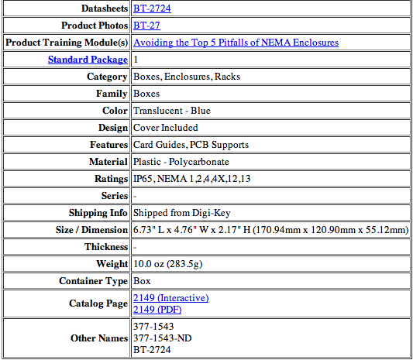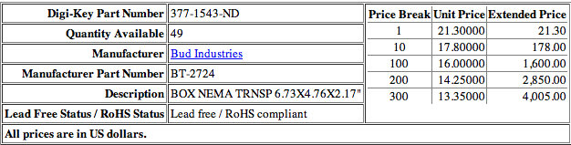
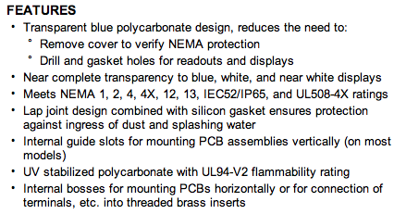
NEMA 4X Cypress Data Sheet

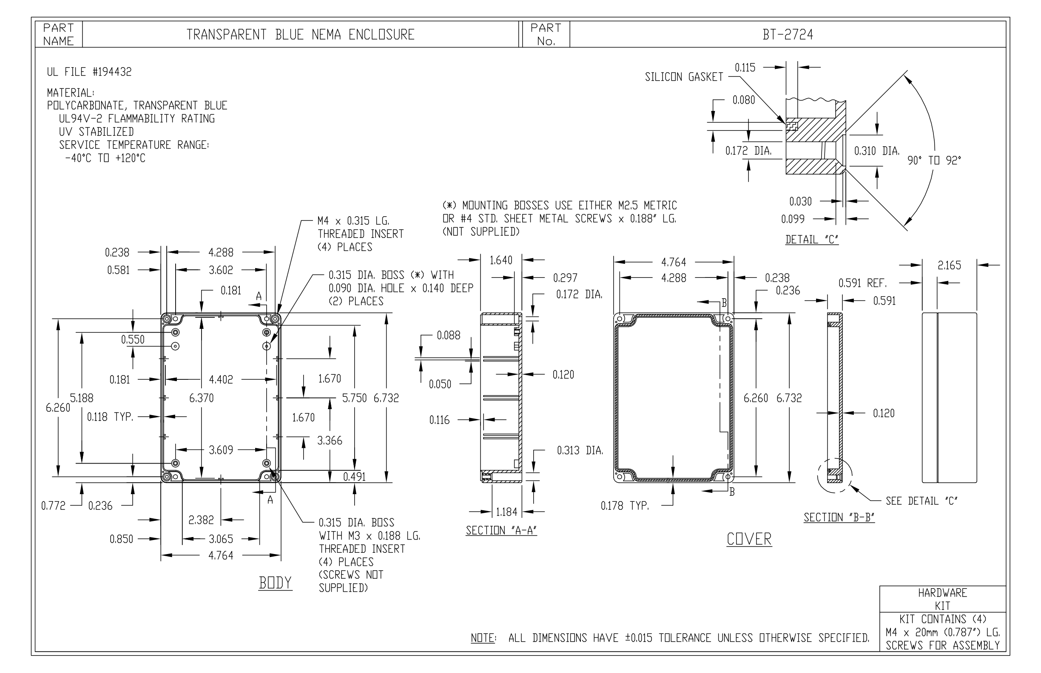

E. Sensor Lesson Plan (Available on TIES website)
TIES MSEE Sensor Lesson Plan
Spring 2008

Objectives

Students will:
- learn what a sensor is and how it works
- learn some applications of sensors, such as PM detection
- relate this information to the SD fires
- create their own sensor and observe its operation
- use a sensor to measure air quality by gathering data

Intro

- Introduce each team member
- Ask the students: Does anyone know what a sensor is?
- Explain in simple terms what a sensor is: A device that detects and measures a physical property, such as weight or light intensity, and responds to it.
- Ask the students if they can come up with their own examples of sensors.
- Talk about measuring air quality and relation to recent fires. Ask students: How did you know when it was safe to go outside? – There is only a small number of air quality monitoring stations in SD County and they only provide hourly average data.
- Pass out and show to students a picture of a smog sensor being used in Orange County as an example of how a sensor works and particularly, one that is used for pollution measurement by cars.
- Pass out and show to students a picture of a Diesel Particulate Filter so they can see a device used to reduce the harmful qualities of exhaust gases from an engine (PM).

Eye Sensor Demonstration

Materials

- Paper or Styrofoam cup
- Water source
- Variable frequency strobe light

Procedure

- Take the paper or Styrofoam cup and pierce a series of small holes in the bottom.
- With the students present pour water into the cup, over the sink. Have the students watch as the water streams out of the holes.
- Ask students to describe the flow of water. Is it continuous or is a series of drops that are acting as a continuous stream?
- Turn off the overhead lights and aim the strobe light at the cup of water. Vary the frequency until the streams of water appear to be droplets.
- Continue to fill the cup and allow the water to flow out of the holes. Now ask the students to describe what they see.

Photo-resistor Sensor Experiment

Materials

- Light Source (Overhead light can be used)
- Digital Multimeter(s)
- 6-10 samples of colored papers
- Alligator clips
- Photo resistor(s)
- Electrical connecting wire

Intro

Does anyone know what electric current is?
Electric current is the flow (movement) of electric charge.

Does anyone know what a resistor is?
A resistor is an electrical component that opposes an electric current. Electrical resistance is a ratio of the degree to which an object opposes an electric current through it, measured in ohms.

Can anyone guess what a photoresistor is?
A photoresistor is a resistor whose resistance decreases with increasing incident light intensity.

Experimental Procedure

(Have students form groups of 4 for this experiment)

- Set the multimeter to measure the resistance of the photo resistor.
- Set the light source up to shine on an area where the paper will be placed. The position of each sheet of paper must be the same.
- Using alligator clips, set photo resistor in a fixed position facing the paper.
- Put down the first sample of colored paper and turn on the light source.
- Record the resistance value.
- Repeat for each sample.

Analysis

- Have students compare their data and determine which colors reflected and/or absorbed more light. Have them explain the relationship between the paper’s reflective properties and resistance.
- Have them list the possible experimental design errors and create a perfect/improved experiment design.

Hand-Held Sensor Experiment

Follow up to the Air Quality Lesson. Students measure air quality around their school.

Intro

- Briefly review topics from the Air Quality Lesson Plan: PM and its health effects.
- Discuss our PM sensor that will be mounted on Preuss rooftop and explain how it works (perhaps draw a picture of the light scattering effect on the board).
- Give a demonstration of how to use the Hand-held PM Sensor.

Materials

- Hand-held PM Sensor

Experimental Procedure

(Have students form group of 4 for this experiment)
- Make a data sheet to record where you take your measurements and the data you will collect from them:
Location:
1
2
3
TOTAL
Average
- Decide on your five locations. Good locations are: inside your classroom, by the bus stop, on the playground, etc.
- Write the name of each location in your data table.
- Visit each location and record the number of particles using the sensor.
- Now you are ready to make a graph of your data. Make a bar graph by writing a scale for the number of particles on the left side (y-axis) and then by drawing a bar up to the correct number of particles for each location. Remember to label each bar of your graph, or make a color key. (Show example)
- Make a large graph of the average results for the entire classroom.
- Which sites had the most particulate matter in the air? Is this what you expected? What do you think this tells you about the relative air quality at each location? Compare this to the results found using the Vaseline squares. Which method is more accurate? Why?

Sensors

Name:

Date:

Eye Sensor Demonstration

1. Describe the flow of water with the lights on. Is it continuous or a series of drops acting as a continuous stream?

2. Describe what you see when only a strobe light illuminates the water.

Photo-resistor Sensor Experiment

1. Which colors reflected and/or absorbed the most light?

2. What is the relationship between the paper’s reflective properties and resistance?

Hand-Held PM Sensor Experiment

Location | Particle Concentration
Which locations had the most particles? Is this what you expected?

Compare this to the results found using the Vaseline squares. Which method is more accurate? Why?

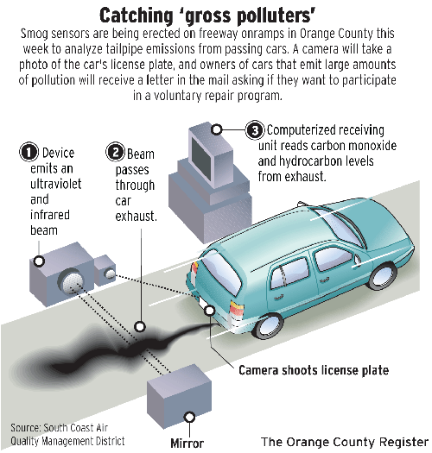

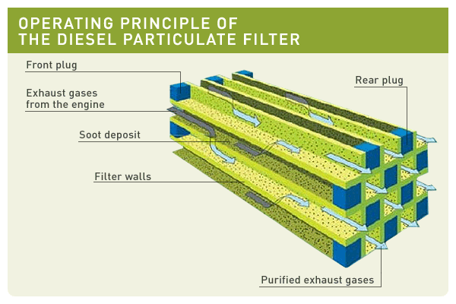

F. Alternative Energy Lesson Plan (Available on TIES website)
TIES MSEE Alternative Energy Lesson Plan
Spring 2008

Objectives

Students will:
- Understand different forms of alternative fuels
- Collect data using a digital multimeter
- Learn about the basic concepts involved with solar energy
- Record and analyze data
- Calculate values of physical quantities using scientific equations

Intro

- Introduce each team member
- Ask the students: does anyone know of any alternative fuels for transportation and why they are better than the gasoline used today?
- Explain all that is discussed below:

Gasoline is the most commonly used fuel for transportation. However, many alternative fuels such as propane, natural gas, electric hybrids, hydrogen fuel cells, and biodiesel are making their way to the market for future use.

These alternative fuels have individual advantages and disadvantages compared to gasoline.

Methanol
Although vehicles can operate on pure methanol fuel, methanol blended with 15 percent unleaded gasoline is more practical. The disadvantage of using methanol however is that a special expensive lubricant such as an SAE 40 lubricant must be used.

Propane
Under normal atmospheric pressure and temperature, propane is a gas. Under moderate pressure and/or lower temperature, propane can be changed into a liquid and can be stored in pressurized tanks. Propane is 270 times more compact in its liquid state than it is as a gas causing it to be portable. Propane has been used as a transportation fuel for more than half a century being the most widely used alternative fuel. For fleet vehicles, the cost of using propane is 5 to 30 percent less than for gasoline.

Ethanol
Because Ethanol has a lower ratio of carbon to non-carbon molecules (hydrogen and oxygen), using it as a fuel additive results in up to 25 percent fewer carbon monoxide emissions than regular gasoline.

Methane
Methane is the natural gas that we use for heating, cooking, drying clothes and water heating. Compressed natural gas (CNG) vehicles emit 85-90 percent less carbon monoxide, 10-20 percent less carbon dioxide, and 90 percent fewer reactive non-methane hydrocarbons than vehicles running on ordinary gasoline. These facts result because natural gas is 25 percent hydrogen molecules (hydrogen gas) by weight. Many fleets such as UCSD shuttles buses and San Diego MTS buses have methane fueling stations.

Electricity
The current problem with electric vehicles continues to be the need for a light battery with large storage capacity, fast recharging, and many recharge cycles without degradation. If too many batteries are used to increase the total energy storage and range of the vehicle, they can weigh down a vehicle reducing its load carrying capacity and causing it to use more energy per mile. Right now, an electric vehicle can only travel about 50 to 130 miles between charges.

Hybrid Electricity
Hybrid Electric Vehicles are powered by two energy sources: an energy conversion unit (e.g. combustion engine or fuel cell) and an energy storage device (e.g. a battery).

Biodiesel
Biodiesel fuel can be used in unmodified diesel engines. It is the fastest growing alternative transportation fuel in the U.S. Biodiesel contains almost no sulfur, so it can reduce sulfur levels in the U.S.’s diesel fuel supply. Currently biodiesel is made from corn and soy, but researchers are looking for non-food based replacements, such as algae and fast growing grasses.

Hydrogen Fuel Cell
Hydrogen may provide as an alternative fuel mix in the future. Space shuttles use hydrogen fuel. Fuel cells use hydrogen and oxygen to produce electricity without harmful emissions because water is the main by-product. However, right now no distribution system is in use is currently in use for vehicles using hydrogen fuel cells. Since hydrogen molecules are so small, the storage is a problem.

Alternative Energy for Transportation

Materials

- Paper, Pen
- Access to the Internet

Procedure

The mayor of San Diego has asked your class to develop a plan to reduce emissions created by his fleet, including school buses, public buses, sanitation trucks, police, emergency vehicles, and the city fleet of automobiles. Divide the project into six parts and in each part develop a plan to present to the mayor, listing recommendations and costs for each type of vehicle and the rationale for each recommendation. List the recommendations of each part by vehicle category. Where there are several recommendations, debate and defend recommendations until a consensus is reached.

Solar Cell Efficiency Experiment

Materials

- Meter Ruler
- 100 - 150W Portable Light Source
- Digital Multimeter(s)
- Small Solar Panel (from Solar Energy Education Kit)

Intro

- Explain what a solar cell/panel is. The efficiency of solar cells is calculated by determining how much of the sun’s energy it converts to electricity
- Introduce basic concepts of voltage and current.
- Give digital multimeter demonstration .

Have you ever used a magnifying glass to make something melt or burn? You were using solar power!

“Solar” is the Latin word for “sun” – and it’s a powerful source of energy. In fact, the sunlight that shines on the Earth in just one hour could meet world energy demand for an entire year!

We can use solar power in two different ways: as a heat source, and as an energy source.

People have used the sun as a heat source for thousands of years. Families in ancient Greece built their homes to get the most sunlight during the cold winter months.

Today we can use solar collectors for heating water in our homes. If you’ve seen a house with big shiny collectors on the roof that are connected to a water pipe, that family is using solar power to heat their swimming pool or shower water.

We can also use solar energy to make electricity. The process is called photovoltaics. If you have a solar-powered watch or calculator, you’re using photovoltaics!

In 1954, scientists at Bell Telephone discovered that silicon (an element found in sand) created an electric charge when it was exposed to sunlight. Just a few years later, silicon chips were used to help power space satellites.

Today, more than 10,000 American families get all of their electricity from solar power. And silicon from just one ton of sand, used in photovoltaic cells, could produce as much electricity as burning 500,000 tons of coal.

You might be wondering why we don’t use solar electricity all the time. Solar power plants only run during the day, unlike coal plants which run day and night. We could build double the solar power plants to produce enough energy during the day but there is no way to store all that energy for the night. So the main issues that prevent us from using solar power permanently is a lack of storage, as well as the fact that it gets very expensive to use. Solar power systems make a different kind of electricity than big power plants do, so different wiring is needed – and that can be expensive.

There are a few big solar power plants in the United States, mostly in California. It’s difficult and expensive to make of electricity using photovoltaics – the panels cost a lot, and a lot of open land is needed.The state of California is providing incentives to reduce the cost of solar power and reward the first people who adopt this technology.

Experimental Procedure

(Have students form groups of 4 for this experiment)

Students will be measuring the efficiency of a solar cell at conditions simulating the sun during the middle of summer, winter, and spring/autumn. Use the following set up for each of the simulated conditions:

To construct a simulator that models the sun’s position in the sky at noon in the middle of summer, place the stand 18cm from the centre of the model, with the lamp at a height of 1m. This creates an 80° angle, which is approximately the altitude of the sun during this time.

To construct a simulator that models the sun’s position in the sky at noon in the middle of spring/autumn, place the stand 38cm from the centre of the model, with the lamp at a height of 0.65m. This creates a 60° angle, which is approximately the altitude of the sun during this time.

To construct a simulator that models the suns position in the sky at noon in the middle of winter, place the stand 87cm from the centre of the model, with the lamp at a height of 0.5m. This creates a 30° angle, which is approximately the altitude of the sun during this time.

- Measure the area of your solar cell in units of mm² (L*W). Record this value in the Data Table.

- Calculate power input to the solar cell. Assume an irradiance of 100 mW/m²

Power In = Irradiance*Area of Cell

- Connect the multimeter to the solar cell

- Set up the light source to simulate summer sun conditions. Turn on the light source.

- Turn the multimeter to 2V DC and measure the voltage (V) of the solar cell. Record this value in the Data Table.

- Turn the multimeter to 200 mA DC and measure the current (I) of the solar cell. Record this value.

- Calculate power output from the cell

Power Output = I*V

- Calculate the efficiency of your solar cell

Efficiency = (Power Out / Power In)*100%

Analysis

- Under which simulated condition did the solar cell exhibit the highest power output? Which condition led to the lowest power output?
- What factors do you think cause the differences in efficiency of the cell?

Energy Chart

A chart comparing different sources of energy is available on the TIES website.

References for Energy Chart:

1.)http://stinet.dtic.mil/oai/oai?verb=getRecord&metadataPrefix=html&identifier=ADA178818
2.)http://www.solartoday.org/2008/may_june08/low_carbon_car.htm
3.)http://www.eere.energy.gov/education/lessonplans/pdfs/transportation_alternativefuels.pdf
4.)http://hypertextbook.com/facts/2002/EricLeung.shtml
5.)http://hypertextbook.com/facts/2003/RoxanneGarcia.shtml
6.)http://209.85.141.104/search?q=cache:HAhjX8NTRtMJ:en.wikipedia.org/wiki/Electric_vehicle+energy+density+of+electric+vehicles&hl=en&ct=clnk&cd=1&gl=us
7.)http://209.85.141.104/search?q=cache:knx_vEle1E4J:www.sandia.gov/LabNews/LN09-08-00/hybrid_story.html+energy+density+of+hybrid+car&hl=en&ct=clnk&cd=1&gl=us
8.)http://209.85.141.104/search?q=cache:C9t6aFbvzjEJ:en.wikipedia.org/wiki/Biodiesel+energy+density+of+biodeisel&hl=en&ct=clnk&cd=3&gl=us
9.)http://209.85.141.104/search?q=cache:C9t6aFbvzjEJ:en.wikipedia.org/wiki/Biodiesel+energy+density+of+biodeisel&hl=en&ct=clnk&cd=3&gl=us
10.)http://209.85.141.104/search?q=cache:dfI9kYBjkCgJ:en.wikipedia.org/wiki/Hydrogen_vehicle+energy+density+of+hydrogen+fuel+cell&hl=en&ct=clnk&cd=3&gl=us
11.)http://www.adb.org/vehicle-emissions/General/Alt-other.asp
12.)http://www.usepropane.com/climate/perc_general_factsheet.pdf
13.)http://findarticles.com/p/articles/mi_qa3864/is_200001/ai_n8894949
14.)http://209.85.141.104/search?q=cache:R8cjUseKe-MJ:seattletimes.nwsource.com/html/localnews/2003697756_plugin08m.html+hybrid+cars+reduce+GHG+emissions&hl=en&ct=clnk&cd=40&gl=us
15.)http://epa.gov/smartway/growandgo/documents/factsheet-biodiesel.htm
16.)http://209.85.141.104/search?q=cache:YCeB1Yr7nYcJ:www.whitehouse.gov/news/releases/2003/02/20030206-2.html+GHG+emissions+of+hydrogen+fuel+cell&hl=en&ct=clnk&cd=5&gl=us
17.)http://www.sustainer.org/dhm_archive/index.php?display_article=vn239moomawed
18.)http://www.motherearthnews.com/Green-Transportation/1972-05-01/Convert-Your-Car-To-Propane.aspx
19.)http://www.highlighthealth.com/eco-friendly/alternative-ethanol-fuel-wont-improve-future-air-quality/
20.)http://www.sciencedaily.com/releases/2002/10/021010065923.htm
21.)http://cr.middlebury.edu/es/altenergylife/electric_car_page.htm
22.)http://209.85.141.104/search?q=cache:tPDEASotydQJ:en.wikipedia.org/wiki/Methanol_economy+storage+of+methanol+compared+to+gasoline&hl=en&ct=clnk&cd=1&gl=us
23.)http://www.iuvmag.com/articles/mar07-2.htm

24.)http://209.85.141.104/search?q=cache:fKVswM78nGcJ:cpcb.nic.in/News%2520Letters/Archives/Alternative%2520Transport/ch2-AT.html+storage+of+ethanol+compared+to+gasoline&hl=en&ct=clnk&cd=5&gl=us
25.)http://209.85.141.104/search?q=cache:A_IH6lC7uBMJ:www.newrules.org/electricity/betterway.html+storage+of+electricity+compared+to+gasoline&hl=en&ct=clnk&cd=3&gl=us
26.)http://209.85.141.104/search?q=cache:Ww8fdqvlq3AJ:www.newcarpark.com/blog/%3Fp%3D59+storage+of+hybrid+car+batteries&hl=en&ct=clnk&cd=20&gl=us
27.)http://www.cambridgebiodiesel.co.uk/index.php?id=3
28.)http://en.wikipedia.org/wiki/Hydrogen_vehicle
29.)http://zfacts.com/p/436.html
30.)http://209.85.141.104/search?q=cache:pw70eEq3WAwJ:www.cleanairtrust.org/E85-Gas-Mileage-Consumption.html+ethanol+mileage&hl=en&ct=clnk&cd=7&gl=us
31.)http://wiki.answers.com/Q/What_causes_global_warming
32.)http://www.thepanamanews.com/pn/v_13/issue_21/science_01.html
33.)http://www.chron.com/disp/story.mpl/business/steffy/4618413.html
34.)http://209.85.141.104/search?q=cache:ICh0Hg3E1UcJ:www.green-trust.org/2000/biofuel/batesmethane.htm+cost+of+methane+compared+to+gasoline&hl=en&ct=clnk&cd=1&gl=us
35.)http://www.ecoworld.com/blog/2006/08/04/electric-car-cost-per-mile/
36.)http://www.hybridcars.com/compressed-natural-gas/cost.html
37.)http://www.ag.ndsu.edu/pubs/ageng/machine/ae1240w.htm
38.)http://www.science.doe.gov/sbir/solicitations/FY%202008/22.EE.Hydrogen.htm

http://stinet.dtic.mil/oai/oai?verb=getRecord&metadataPrefix=html&identifier=ADA178818
http://www.solartoday.org/2008/may_june08/low_carbon_car.htm http://www.eere.energy.gov/education/lessonplans/pdfs/transportation_alternativefuels.pdf
www.powerhousekids.com

